Demore, McFadden

ECE332 – Lab 15s

MatLab Code:

%setup

clear all

format compact

s = tf('s');

H = (20000*(s+100))/((s+500)*(s+10000));

%Pole-Zero Plot

pzmap(H)

grid on

title('Pole-Zero Plot for H(s)')

figure

%Step Response Plot

step(H)

grid on

title('Step Response for H(s)')

figure

%Bode Plot

bode(H)

grid on

title('Bode Plot for H(s)')

%Laplace Transform

syms s t

Ht = (20000*(s+100))/((s+500)*(s+10000));

h = ilaplace(Ht);

pretty(h)

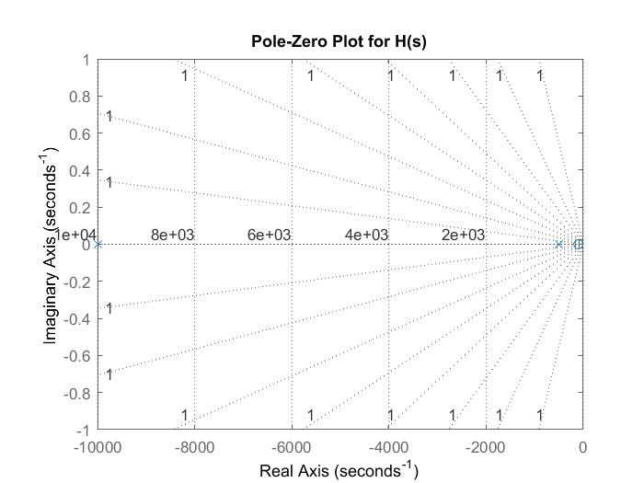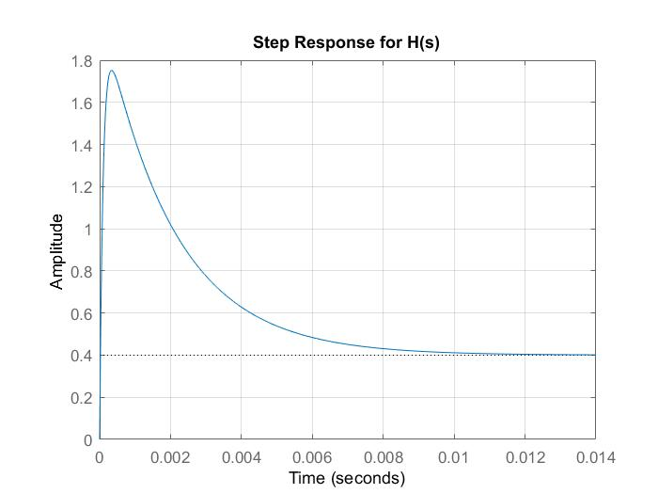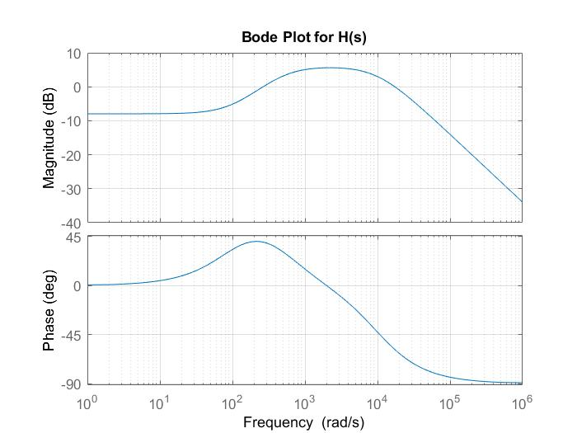

Laplace Transform of H(s):

exp(-10000 t) 396000 exp(-500 t) 16000

-------------------- - -----------------

19 19

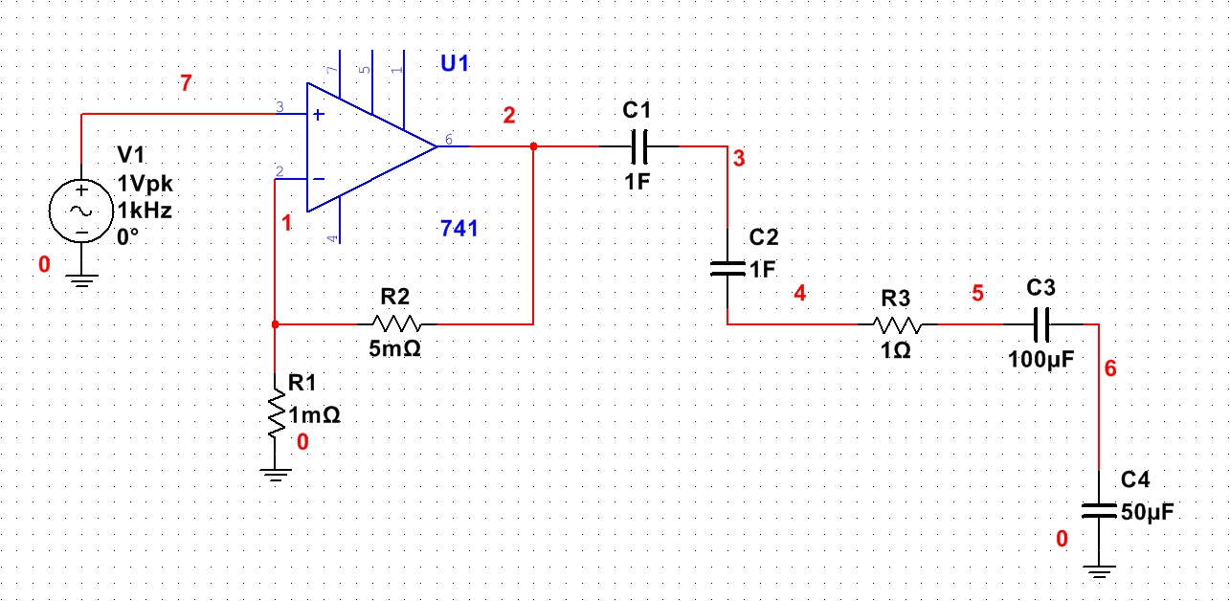

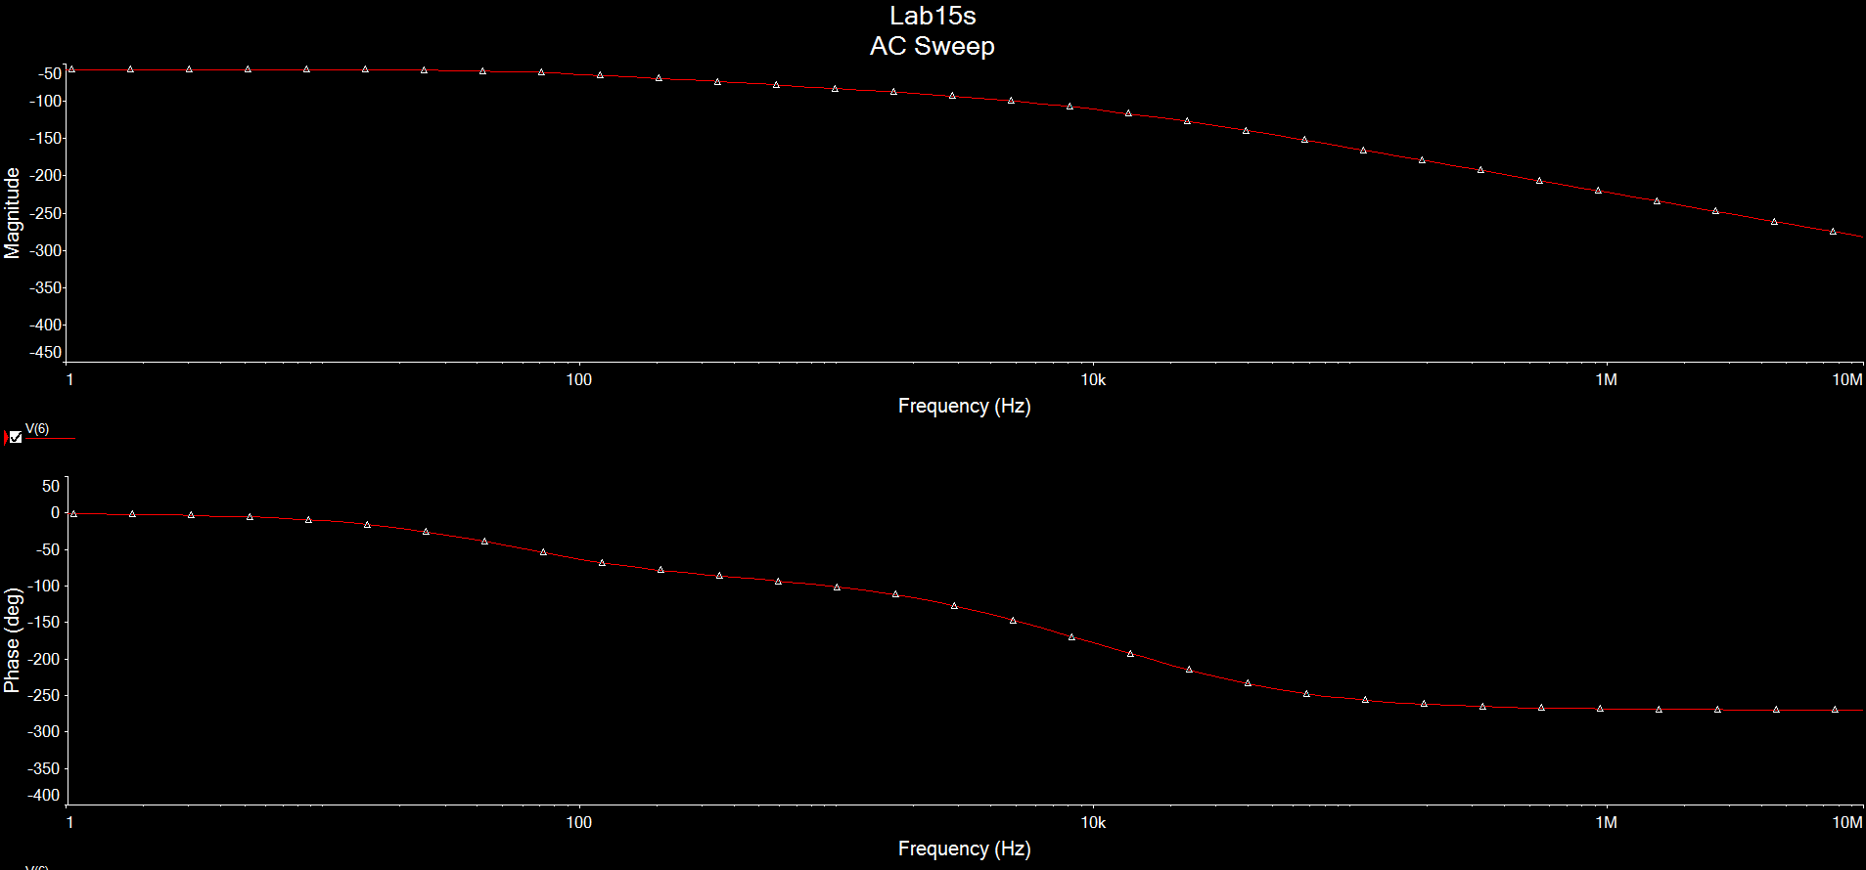

|  |  |  |  |  |
| --- | --- | --- | --- | --- |
|  | Parameter | Matlab | Simulate | % Error |
| Step  Response | *ts* (*ms*)  Final Value | 8  0.4 | null | null |
| Freq  Response | *ωc1* (*rad/s*)  *ωc2* (*rad/s*)  K(V/V) | 10  100  1.75 | null | null |